**Planning Proposal**

**Business Zones – 2A Main Road, Boolaroo**

**Lake Macquarie Local Environmental Plan 2014 (Amendment No XX)**

**Pre-Gateway version**

|  |  |
| --- | --- |
| **Local Government Area:** | Lake Macquarie City |
| **Name of Draft LEP:** | Lake Macquarie Local Environmental Plan 2014 (Amendment No XX) |
| **Subject Land:** | 2A Main Road, Boolaroo (Part of Lot 599 DP 1228699) |
| **Land Owner:** | PASMINCO COCKLE CREEK SMELTER PTY LIMITED |
| **Applicant:** | Lake Macquarie City Council (LMCC) |
| **Council Reference Number:** | RZ/10/2018 |
| **Document Date:** | August 2019 |
| **Document Author:** | Andrew Donald – Senior Strategic Planner |

Table of Contents

Part 1 – OBJECTIVES OR INTENDED OUTCOMES 3

Part 2 – EXPLANATION OF PROVISIONS 3

Part 3 – JUSTIFICATION 3

Section A – Need for the Planning Proposal 3

Section B – Relationship to Strategic Planning Framework 4

Section C – Environmental, Social and Economic Impact 11

Section D – State and Commonwealth Interests 11

Part 4 - MAPPING 12

Map 1- Locality Map 12

Map 2- Aerial Photograph 13

Map 3- Existing Land Zoning Map 14

Map 4- Proposed Land Zoning Map 15

Map 5- Existing Lot Size Map 16

Map 6- Proposed Lot Size Map 17

Map 7- Existing Height of Building Map 18

Map 8- Proposed Height of Building Map 19

Part 5 – COMMUNITY CONSULTATION 20

Part 6 – PROJECT TIMELINE 20

# Part 1 – OBJECTIVES OR INTENDED OUTCOMES

The Planning Proposal applies to vacant, remediated land within the former Pasminco Cockle Creek Smelter site at Boolaroo. It seeks to amend the *Lake Macquarie Local Environmental* *Plan* (*LMLEP*) 2014 to rezone the subject land (approximately 20 ha) to enable specialised retail premises and other commercial uses that require a large floor area. The proposal also seeks to establish a suitable interface between the proposed business zones and the adjacent residential zone.

The land is to be rezoned from R2 Low Density Residential, R3 Medium Density Residential and B4 Mixed Use to B7 Business Park and B4 Mixed Use.

# Part 2 – EXPLANATION OF PROVISIONS

The provisions in this planning proposal will amend LMLEP 2014 as outlined below:

|  |  |
| --- | --- |
| **Amendment Applies to** | **Explanation of provision** |
| Part of Lot 599 DP 1228699 | * Change the land use zone applying to the subject land variously from R2 Low Density Residential, R3 Medium Density Residential and B4 Mixed Use to B7 Business Park and B4 Mixed Use * Change the Lot Size Map variously from 450m2and 900m2 to 1500m2 and no minimum lot size. * Change the Height of Building Map variously from 8.5m, 10m and 13m to 15m and 13m. |

# Part 3 – JUSTIFICATION

## Section A – Need for the Planning Proposal

1. ***Is the planning proposal a result of any strategic study or report?***

No. The subject land forms part of the former Pasminco Cockle Creek Smelter site, which was rezoned in two stages, with the associated amendments to Lake Macquarie LEP 2004 being finalised in 2010 and 2011 respectively. The zones applied by those LEP amendments were based on a master plan originally submitted by the proponent in 2008.

Since that time, the potential for the subject land to support certain commercial activities requiring a large floorplate and site area has become apparent. Increasing the ratio of commercial to residential zoned land within the former smelter site is in keeping with Council’s original intention to facilitate employment-generating land uses on a site that historically supported a significant number of jobs.

The proposal is also consistent with outcomes being sought within an identified “North West Lake Macquarie Catalyst Area”, which has bilateral support from Council and the Department of Planning and Industry.

1. ***Is the planning proposal the best means of achieving the objectives or intended outcomes, or is there a better way?***

Yes. The proposed rezoning provides scope for remediated, vacant land to be developed for regionally-significant specialised retail and other commercial uses which are currently not possible under the predominantly residential zoning.

## Section B – Relationship to Strategic Planning Framework

1. ***Is the planning proposal consistent with the objectives and actions of the applicable regional or sub-regional strategy?***

Hunter Regional Plan 2036

The primary purpose of the Hunter Regional Plan (HRP) 2036 is to cater for the future development of the region ensuring that adequate land is available and appropriately located to accommodate the region’s growing population and employment needs.

The HRP contains numerous directions to guide planning decisions. Direction 24: *Protect the economic functions of employment land* is relevant to this Planning Proposal. Direction 24 is supported by actions to “Locate new employment land so that it does not conflict with surrounding residential uses”, and to “Provide for mixed use opportunities and themed employment precincts in local plans”.

The proposal is consistent with these actions in that it provides for a new employment precinct including an area zoned for mixed use development. The mixed use zoning provides a buffer between the proposed business park zone and an adjacent area zoned for residential development.

The Local Narratives section of the HRP includes a number of priorities for each Council in the region regarding both centres & employment, and housing. Priorities for the Cardiff-Glendale strategic centre include:

* *Plan for development as an emerging strategic centre that will provide services to the growing Newcastle – Lake Macquarie Western Corridor, deliver renewal in Cardiff and redevelop the former industrial lands at Boolaroo.*
* *Leverage the existing good access to employment and services in the metropolitan area and commuter connections to the Upper Hunter Valley and Central Coast.*

The Planning Proposal will support employment-generating development of the former industrial lands at Boolaroo that leverages the strategic locational advantages of the site.

Greater Newcastle Metropolitan Plan 2036

The Greater Newcastle Metropolitan Plan (GNMP) 2036 recognises that “a positive legacy of Greater Newcastle’s industrial and heavy manufacturing past is land and infrastructure in large land holdings in central locations”. The former Pasminco Cockle Creek Smelter site at Boolaroo is one such example.

The Planning Proposal is consistent with Action 7.1 in the GNMP which calls on Councils to:

* *Build capacity for new economy jobs in areas well serviced by public transport and close to established centres by:*
* *Enabling a greater range of employment generating uses in appropriate industrial and business areas, and*
* *Ensure an adequate supply of employment land, including industrial zoned land, to cater for demand of urban services in accessible locations.*

The proposal also aligns with the outcomes envisaged for the so-called Munibung Precinct within the “North West Lake Macquarie Catalyst Area”, articulated in the GNMP as follows:

Lake Macquarie City Council will:

* *Align local plans to facilitate urban renewal through increased housing density and mixed-use including large format retail and office uses, and*
* *Explore options to improve pedestrian connections to Cockle Creek Train Station with Transport for NSW.*

1. ***Is the planning proposal consistent with a council’s local strategy or other local strategic plan?***

Lake Macquarie City Community Strategic Plan 2017-2027

The Lake Macquarie City Community Strategic Plan 2017-2027 has been developed with the people of Lake Macquarie outlining the vision and values of the community and providing clear strategies to achieve this.

The recently adopted Community Strategic Plan recognises the importance of a diverse economy as a key value for the Local Government Area. The Planning Proposal is consistent with this value as the planning proposal will create opportunities for a range of specialised retail and commercial uses that will create local employment and a broader economic base for the City.

Imagine Lake Mac Strategy

Imagine Lake Mac has recently been adopted as Council’s preeminent land use planning document (superseding Lifestyle 2030).

Imagine Lake Mac contains a number of aspirations for the City to guide future development. These include “A city of prosperity – that attracts investment, creates jobs, and fosters innovation”. This aspiration is accompanied by a number of actions and performance measures.

The Planning Proposal aligns with several of these actions, including:

* Encourage long term, sustainable economic growth that capitalises on the City’s unique value propositions
* Closely monitor changes in the local, national, and global economies, and respond appropriately
* Maximise the potential of existing infrastructure and natural assets to encourage investment, and economic and employment growth
* Provide sufficient land for a range of employment activities, including industrial precincts in accessible locations

The Planning Proposal may also contribute to relevant performance indicators, such as:

* Increase in percentage of the workforce that lives and works in the city
* Increased proportion of people employed
* Increase in number of people employed in key growth industries
* Increased economic activity in knowledge intensive and non-traditional industries, such as the creative sector, and those that contribute to a ‘circular economy’
* 15 years supply of well-located employment generating land and floor space

The site of the Planning Proposal is within the area identified in Imagine Lake Mac as the North West Lake Macquarie Catalyst Area (also featured in GNMP 2036), and is specifically located in the Munibung Precinct. The proposal is consistent with outcomes envisaged for this precinct, which include:

* Mixed use, residential development, and other employment opportunities occur in a range of scales
* Large format retail developed in select locations

Lake Macquarie Development Control Plan 2014 – Pasminco Area Plan

The purpose of the Pasminco Area Plan is to guide the redevelopment of the former Pasminco Cockle Creek Smelter site and the former Incitec Pivot Fertilizer site.

As the Area Plan reflects the current zoning in place for the site, the rezoning envisaged in this Planning Proposal will necessitate an amendment to the Area Plan.

1. ***Is the planning proposal consistent with applicable State Environmental Planning Policies?***

The table below indicates State Environmental Planning Policies (SEPPs) considered relevant to the Planning Proposal.

|  |  |  |
| --- | --- | --- |
| SEPP | Relevance | Implications |
| **SEPP (Coastal Management) 2018** | The aim of this policy is to promote an integrated and co-ordinated approach to land use planning in the coastal zone in a manner consistent with the objects of the [*Coastal Management Act 2016*](https://www.legislation.nsw.gov.au/#/view/act/2016/20)*,* | As part of the site is within the Coastal Environment Area as defined by the SEPP, consideration must be had to Clause 13 of the SEPP prior to the granting of development consent. |
| SEPP No 55—Remediation of Land | The aim of this policy is to promote the remediation of contaminated land for the purpose of reducing the risk of harm to human health or any other aspect of the environment.  The SEPP was recently updated to include a clause entitled: *Perpetual care arrangements required for development at former zinc and lead smelter and fertiliser production site at Boolaroo, Lake Macquarie* | The SEPP provides that consent may not be granted for development on the land the subject of this planning proposal unless the Planning Secretary has certified that adequate arrangements are in place for the perpetual care of the containment cell and various other land. |

1. ***Is the planning proposal consistent with applicable Ministerial Directions (s. 9.11 directions)?***

The Planning proposal is consistent with all relevant ministerial directions as outlined in the table below.

|  |  |  |
| --- | --- | --- |
| Ministerial Direction | Objective/s | Consistency / Comment |
| **1.1 Business and Industrial zones** | 1) encourage employment growth in suitable locations, 2) protect employment land in business and industrial zones, 3) support the viability of identified strategic centres | The Planning Proposal is consistent with this direction as the zoning change encourages employment opportunities and supports the objectives of the North West Lake Macquarie Catalyst area. |
| **2.2 Coastal Protection** | Implement the principles in the NSW Coastal Policy | The Planning Proposal is consistent with this direction as it is not within a coastal hazard area and is consistent with relevant provisions of NSW Coastal Policy. |
| **3.1 Residential zones** | (a) to encourage a variety and choice of housing types to provide for existing and future housing needs,  (b) to make efficient use of existing infrastructure and services and ensure that new housing has appropriate access to infrastructure and services,  (c) to minimise the impact of residential development on the environment and resource lands. | The Planning Proposal is inconsistent with the direction in that it seeks to rezone approximately 15 hectares from a residential zone to a business zone.  This inconsistency is considered justified given:   * the remaining 66 hectares of vacant residential land available adjacent to the site * the proposed business zones better reflect the outcomes envisaged for the precinct in the Greater Newcastle Metropolitan Strategy. |
| **3.4 Integrated Land Use and Transport** | (a) improving access to housing, jobs and services by walking, cycling and public transport, and  (b) increasing the choice of available transport and reducing dependence on cars, and  (c) reducing travel demand including the number of trips generated by development and the distances travelled, especially by car, and  (d) supporting the efficient and viable operation of public transport services, and  (e) providing for the efficient movement of freight | The Planning Proposal is consistent with this direction as the proposed business zones will enable development that can utilise the nearby Cockle Creek railway station and public bus routes along Main Road. |
| **4.1 Acid Sulfate Soils** | Avoid significant adverse environmental impacts from the use of land that has a probability of containing acid sulfate soils. | The subject site is identified in LMLEP 2014 maps as having class 5 Acid Sulfate Soils. The Planning Proposal is consistent with the direction as Council’s LEP and DCP already contain appropriate controls to ensure potential Acid Sulphate Soils are minimised, which will be addressed at the development application stage. |
| **4.2 Mine Subsidence and Unstable Land** | Prevent damage to life, property and the environment on land  identified as unstable or potentially subject to mine subsidence. | As the subject land is within a mine subsidence district, consultation with Subsidence Advisory NSW will be necessary. |
| **5.10 Implementation of Regional Plans** | Give legal effect to the vision, land use strategy, goals, directions and actions contained in Regional Plans. | The proposal is consistent with the Hunter Regional Plan, as outlined in Section B of this document. |
| **6.1 Approval and Referral Requirements** | Ensure that LEP provisions encourage the efficient and appropriate assessment of development. | The proposal is consistent with the direction as it does not contain any provisions that require concurrence, or identify development as ‘designated’. |
| 6.2 Reserving Land for Public Purposes | To facilitate the provision of public services and facilities by reserving land for public purposes, and to facilitate the removal of reservations of land for public purposes where the land is no longer required for acquisition. | The proposal is consistent with the direction as it does not alter or reduce existing zonings or reservations of land for public purposes. |

## 

## Section C – Environmental, Social and Economic Impact

1. ***Is there any likelihood that critical habitat or threatened species, populations or ecological communities, or their habitats, will be adversely affected as a result of the proposal?***

No. The subject site is a recently remediated former heavy industrial site and, as such is devoid of vegetation.

1. ***Are there any other likely environmental effects as a result of the planning proposal and how are they proposed to be managed?***

No. There are no likely environmental effects of the planning proposal that will require management.

1. ***How has the planning proposal adequately addressed any social and economic effects?***

Social

The proposed rezoning will facilitate the development of a business park providing for specialised retail premises and other commercial uses that require a large floor area. It also includes zoning to allow a strip of mixed use development fronting the residential collector road which forms the southern edge of the subject land. This element provides for a buffer to be created between the business park and the adjacent residential area.

The proposed uses will generate much-needed employment opportunities for the growing population in the north west sector of the City.

It is noted that the Pasminco Area Plan, within the Lake Macquarie Development Control Plan 2014, identifies the requirement for a 0.5 hectare local park to be established within (or in the vicinity of) the land the subject of this planning proposal. This requirement will be re-considered as part of an amendment to the Area Plan to reflect the proposed rezoning of the subject land.

Economic

The proposed rezoning will result in a net increase of 15 hectares of employment land in a strategic location within the North West Lake Macquarie Catalyst Area. The business park will complement the existing Bunnings Warehouse immediately north of the subject land, and will support the nearby Cardiff-Glendale strategic centre. The strip of land proposed to be zoned for mixed use provides for a variety of commercial and some residential uses that will further enhance the economic potential of the locality.

Lake Macquarie currently has a total of 138 hectares of land zoned B7 Business Park. An analysis of existing B7 land within the LGA (below) shows that this land is either fully developed, has DA approval, or is greater than 25km from the subject site.

|  |  |  |  |
| --- | --- | --- | --- |
| *B7 zoned land - Location* | *Area (ha)* | *Development status* | *Distance from subject land (km)* |
| Pennant Street, Cardiff | 13 | Developed | 3 |
| Macquarie/Hillsborough Road, Warners Bay | 35 | Developed | 7 |
| Medcalf St, Warners Bay | 9 | Developed | 6 |
| Groves Road, Bennetts Green | 9 | Developed | 12 |
| Pacific Highway, Bennetts Green | 13 | DA approved | 12 |
| Pacific Highway, Belmont North | 10 | Developed | 14 |
| Gateway Boulevard, Morisset | 12 | Developed | 30 |
| Gimberts Road, Morisset | 37 | Undeveloped | 30 |

## Section D – State and Commonwealth Interests

1. ***Is there adequate public infrastructure for the planning proposal?***

Yes. The subject land is currently serviced with all essential infrastructure and has direct access to the regional road network (MR 217). It is also less than 400 metres from the Cockle Creek train station. A traffic impact study will be prepared to inform any requirements for upgrades to the transport network.

1. ***What are the views of State and Commonwealth public authorities consulted in accordance with the Gateway determination?***

It is anticipated consultation will be undertaken with the following agencies:

* Roads and Maritime Services
* Subsidence Advisory NSW
* Hunter Water Corporation

# Part 4 - MAPPING

## Map 1- Locality Map

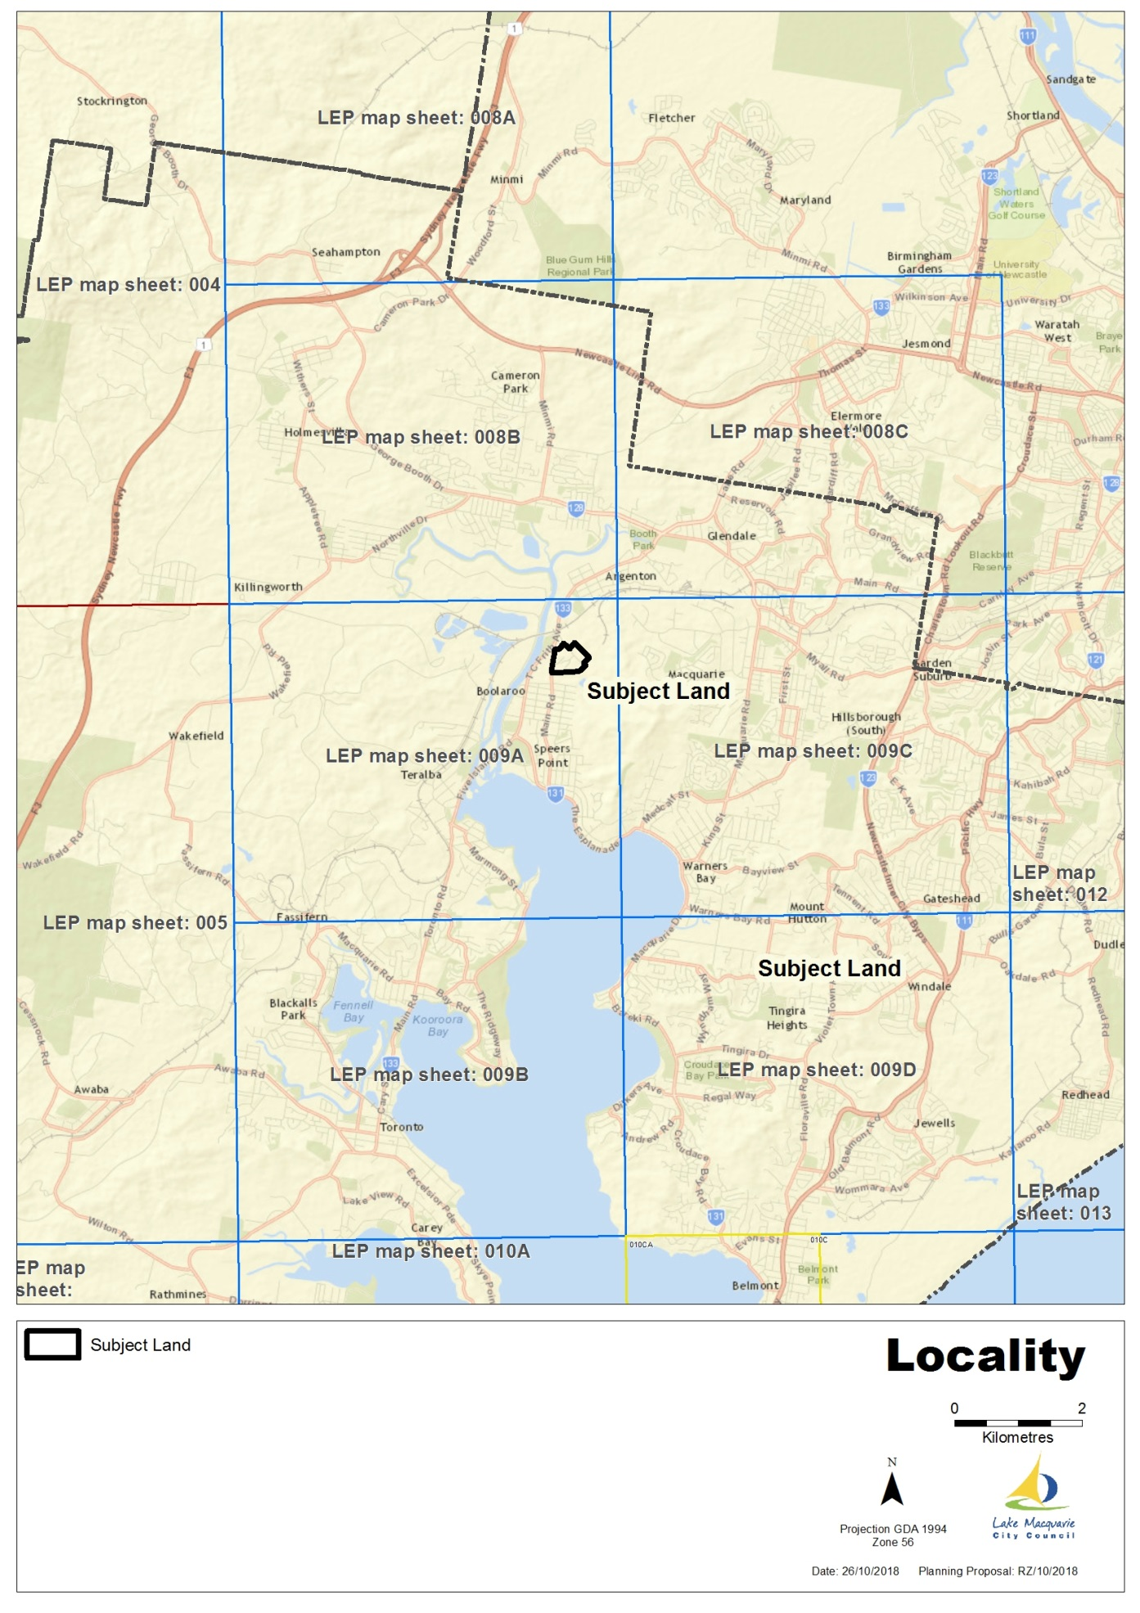

## Map 2- Aerial Photograph

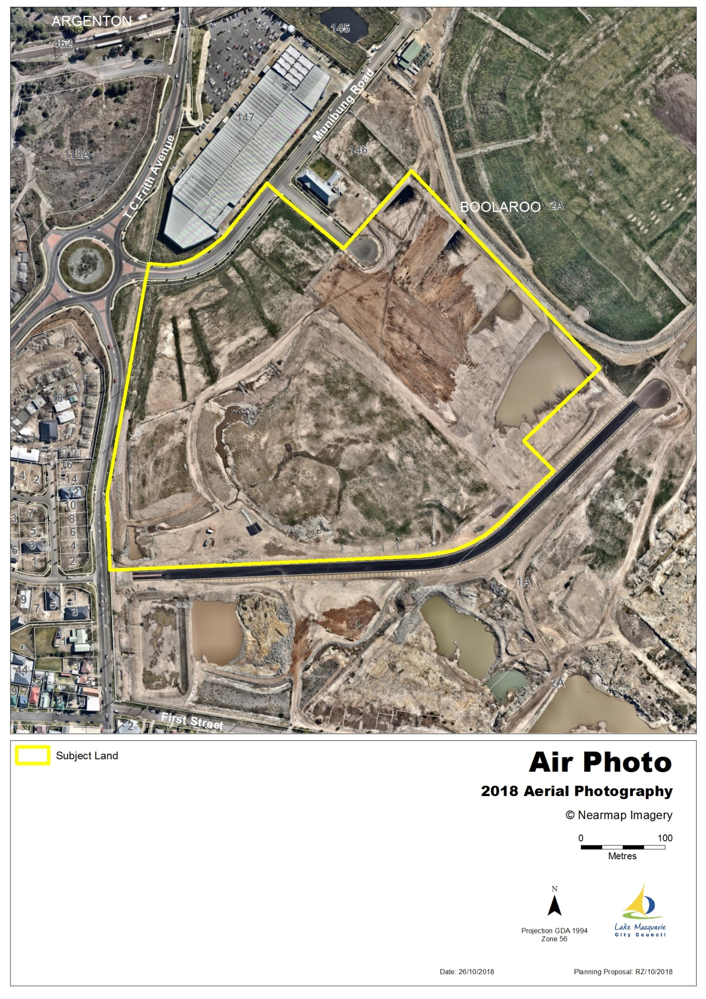

## Map 3- Existing Land Zoning Map

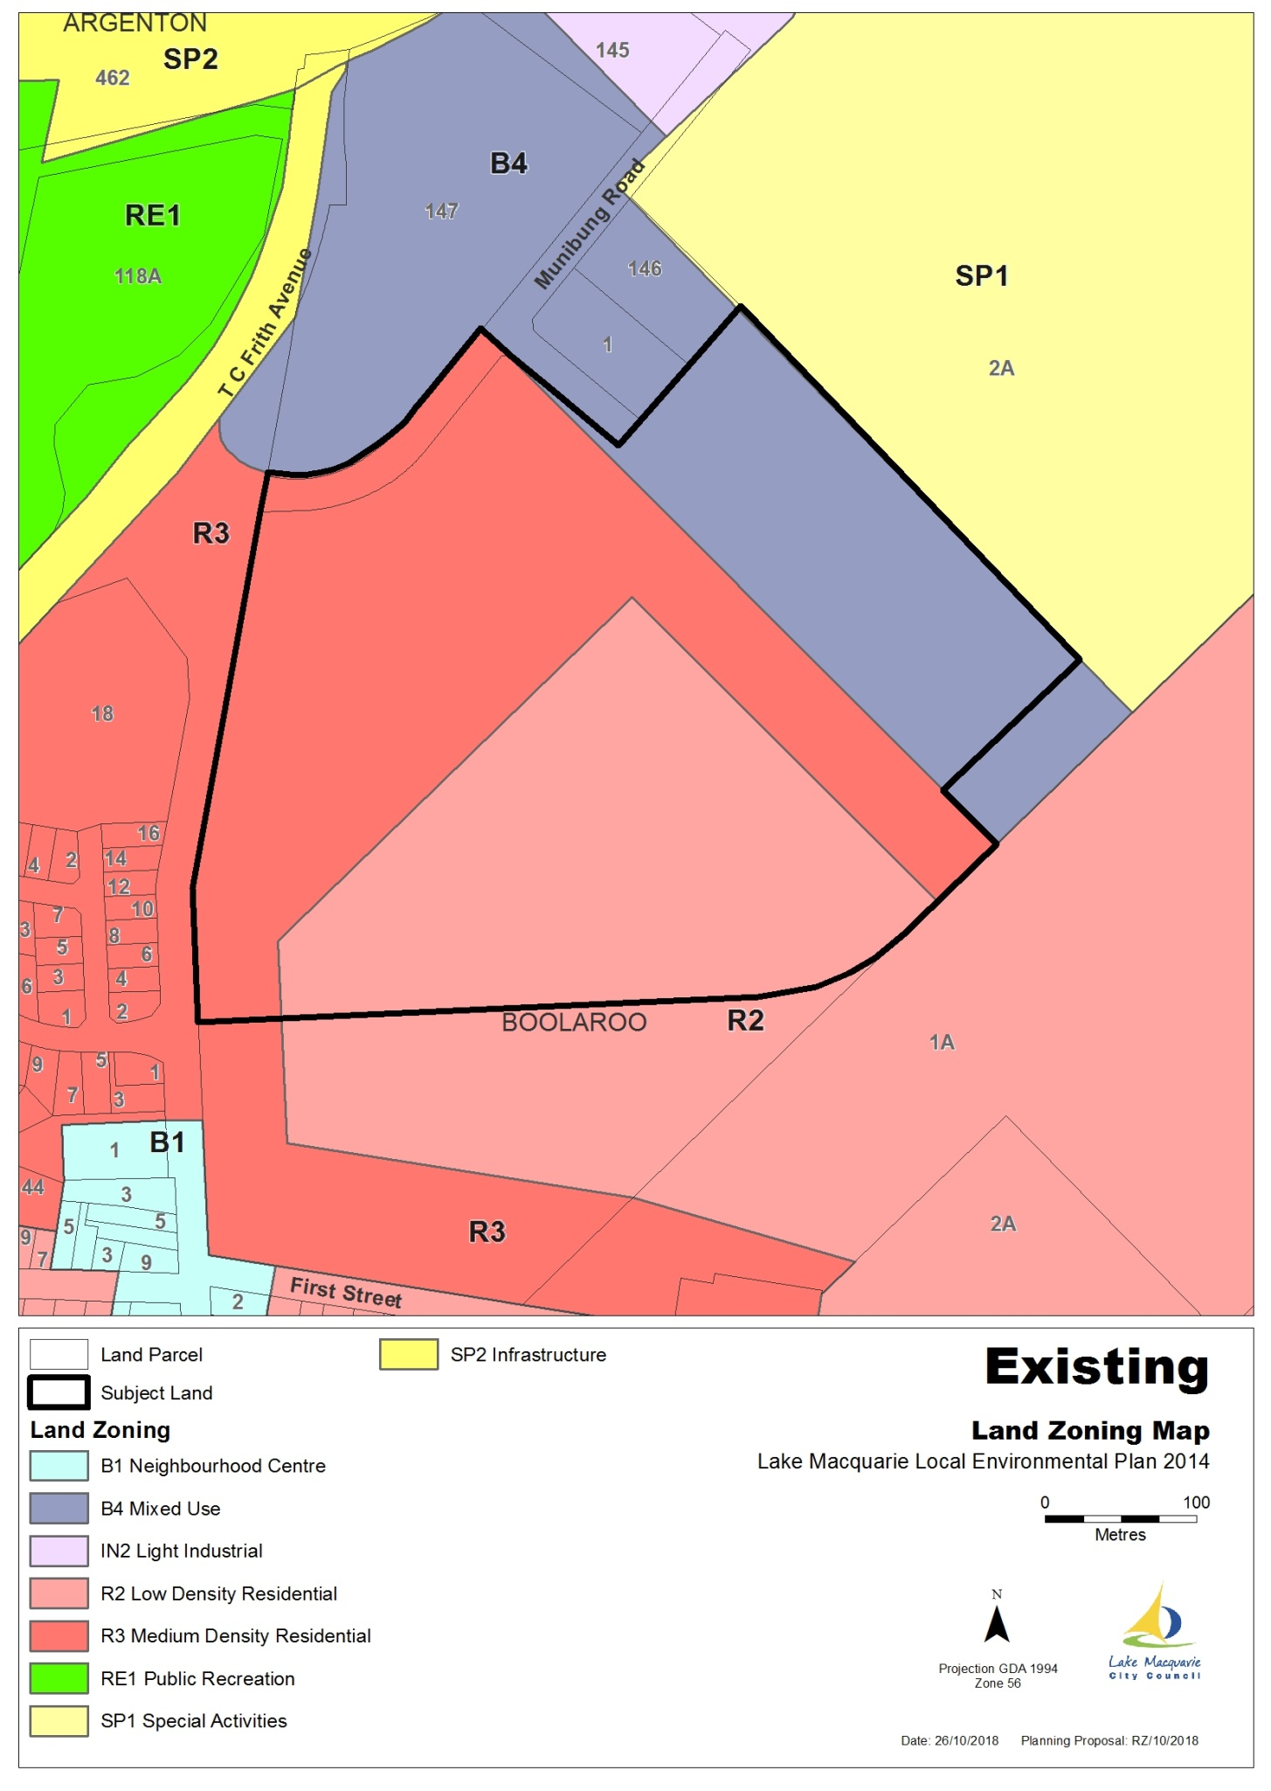

## Map 4- Proposed Land Zoning Map

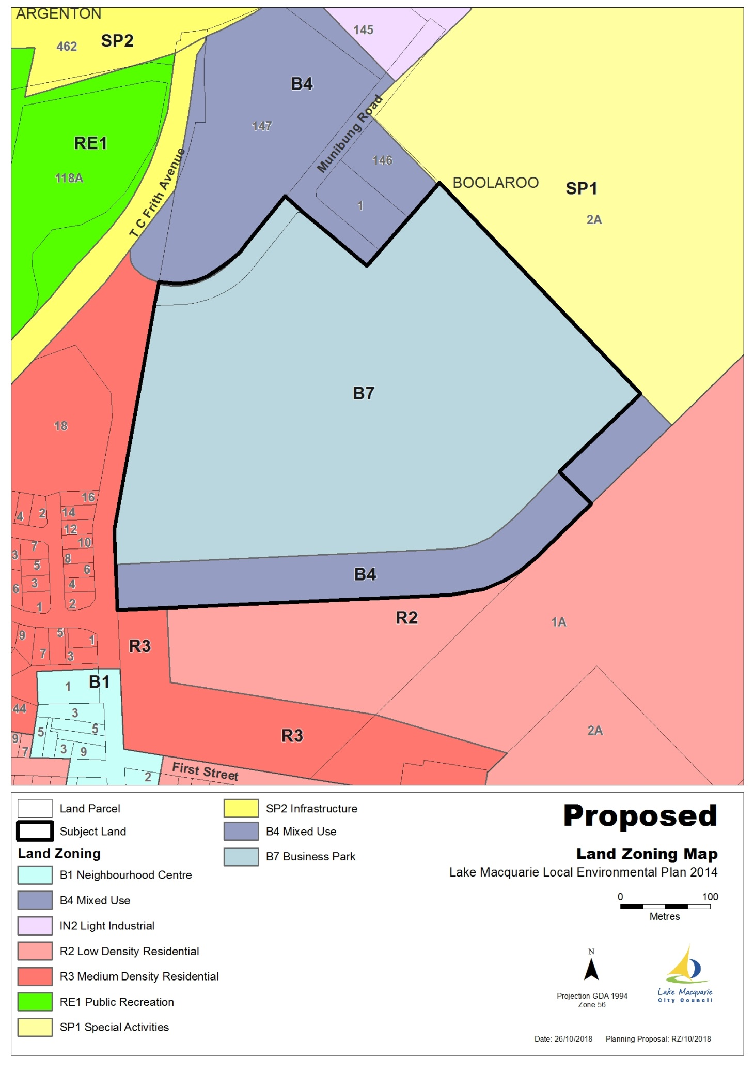

## Map 5- Existing Lot Size Map

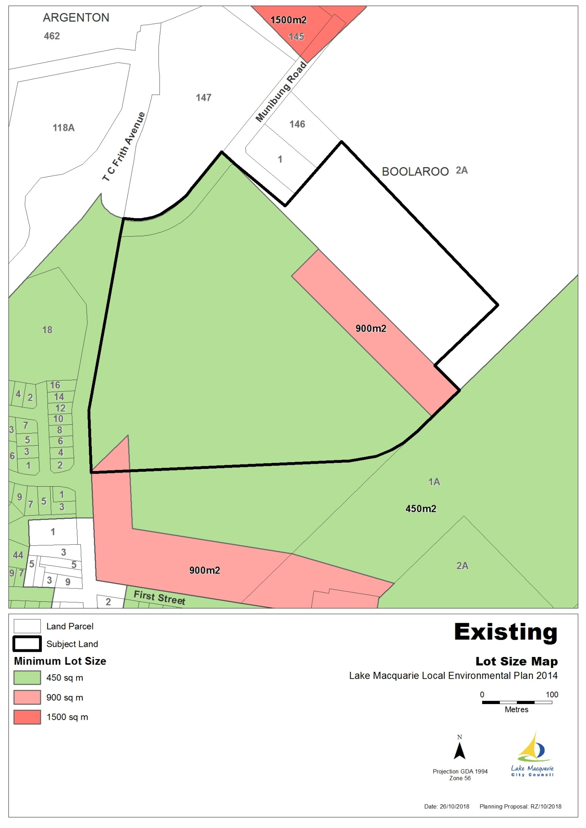

## Map 6- Proposed Lot Size Map

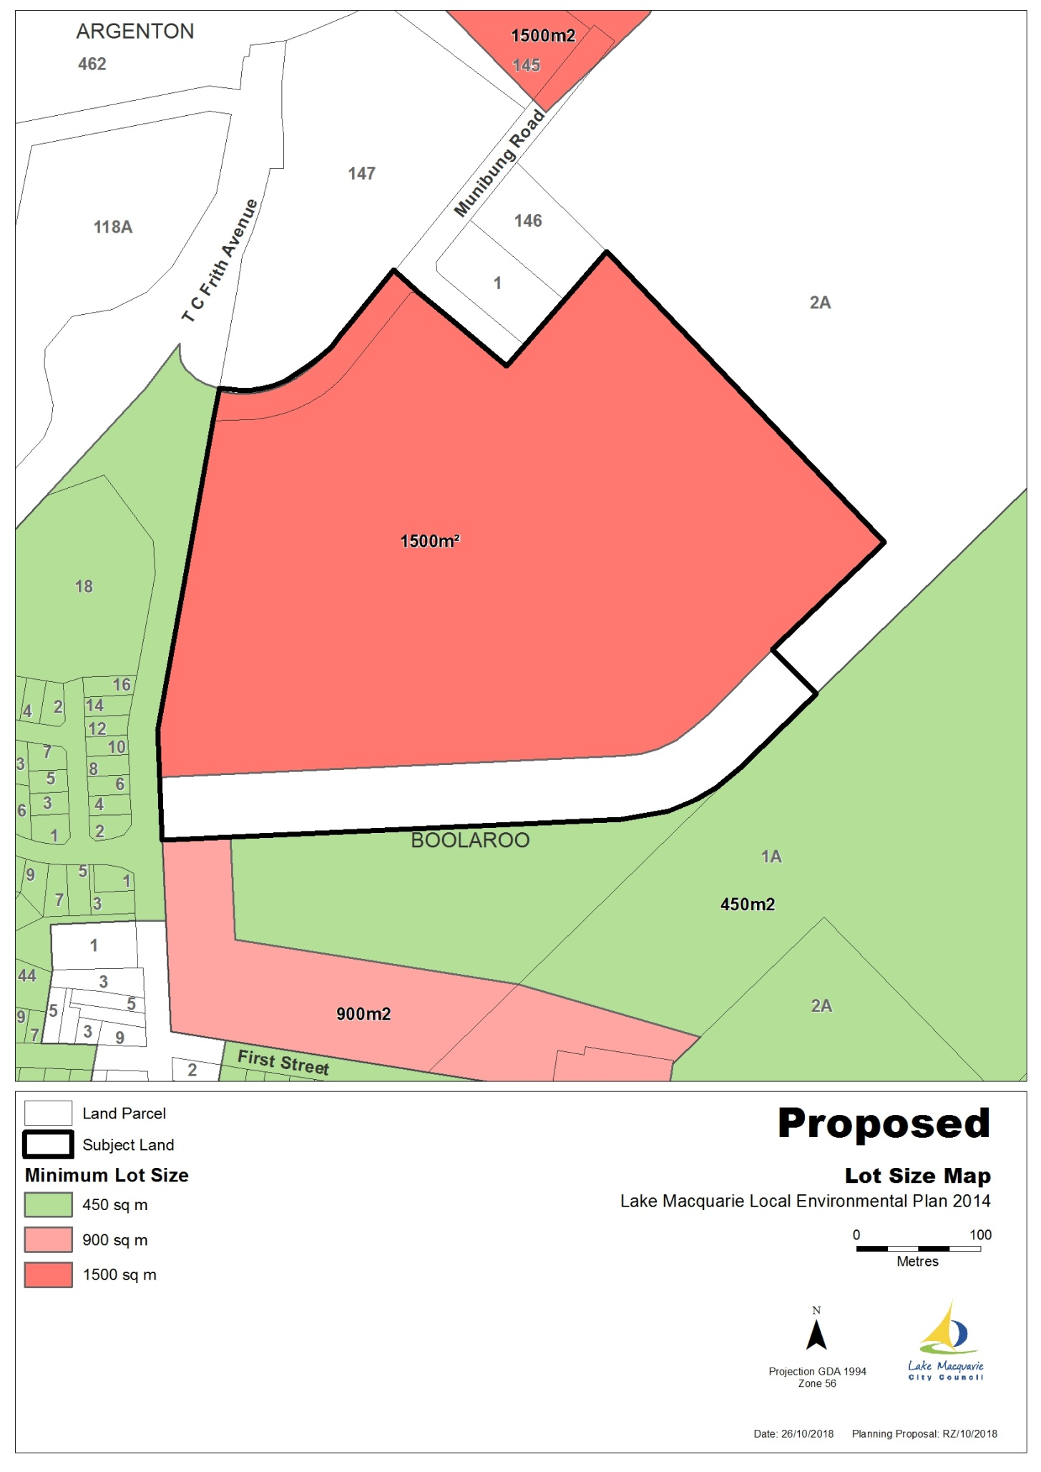

## Map 7- Existing Height of Building Map

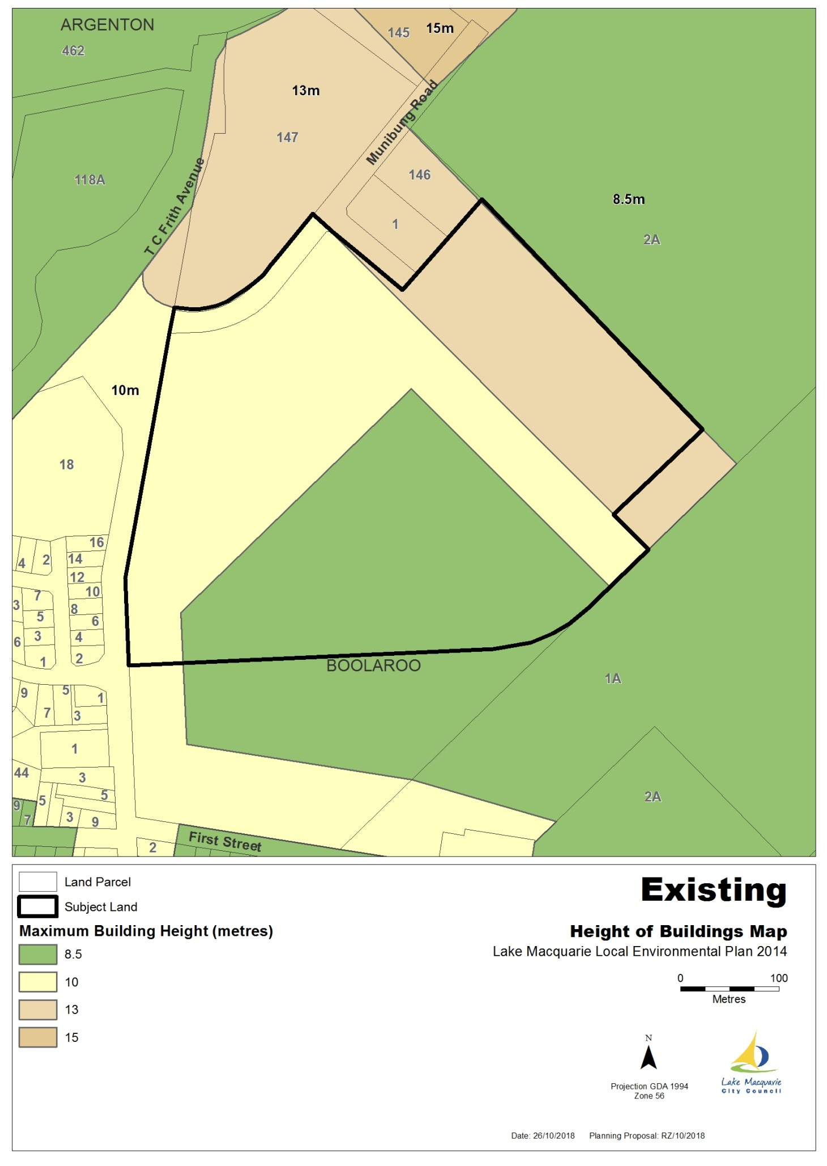

## Map 8- Proposed Height of Building Map

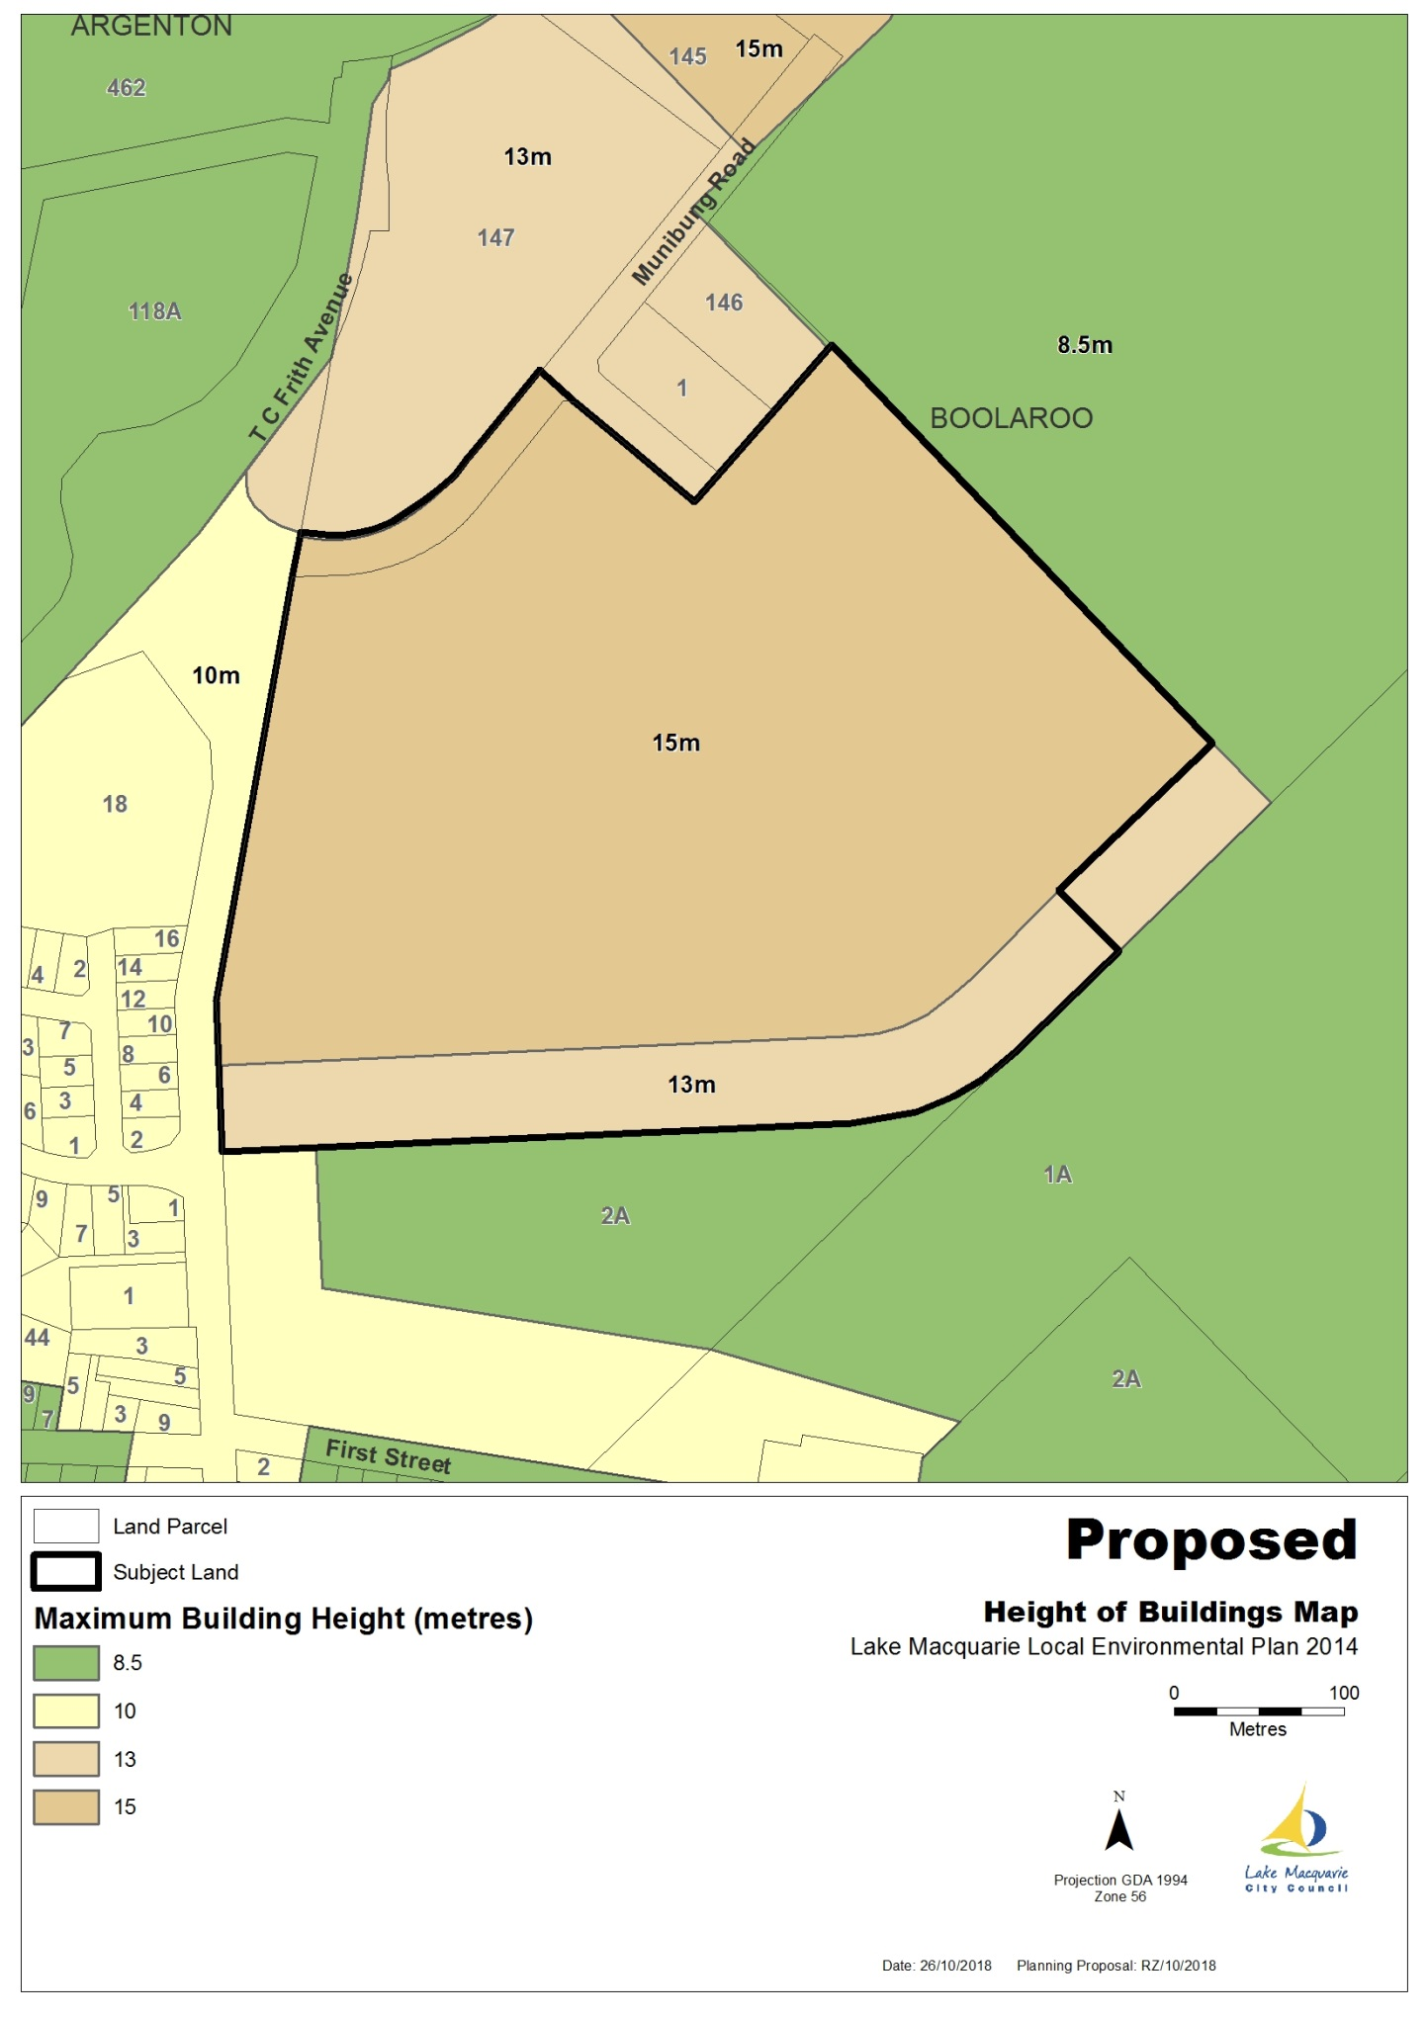

# Part 5 – COMMUNITY CONSULTATION

It is anticipated the Planning Proposal will be publicly exhibited for at least 14 days in accordance with requirements of the Gateway Determination.

# Part 6 – PROJECT TIMELINE

|  |  |
| --- | --- |
| Action | Timeframe (forecast) |
| Gateway determination to proceed | October 2019 |
| Government agency consultation | November 2019 |
| Public exhibition (28 days) | December 2019 |
| Consideration of submissions | February 2020 |
| Report public exhibition findings to Council | March 2020 |
| Finalisation of LEP Amendment | May 2020 |